Session analysis abstract
# | Analysis | Deliverables
1 | TPM normalisation harmonisation of ssGSEA | Fig 1 (concordance), Table S_TPM_concordance
2 | PERMANOVA variance partition of ecotype vs subgroup | Fig 2 (donut + bar), Table S_PERMANOVA
3 | Cox ecotype × cohort_group interaction + subtype-stratified survival | Fig 3 (KM + forest), Table S_subtype_stratified
4 | IPW sensitivity for differential OS missingness | Fig 4 (3-panel), Fig 5 (Love plot), Table S_IPW_altweights
5 | IDH1/IDH2 mutation audit | Text summary, Table S_IDH_audit
6 | Molecular subgroup × anatomical location × ecotype | Fig 6, Table S_location_crosstab
7 | Location-stratified Kaplan–Meier by ecotype | Fig 7
8 | Location-aware Cox model (baseline vs +location) | Text + Table S_Cox_with_location

Figure 1 | TPM normalisation harmonisation
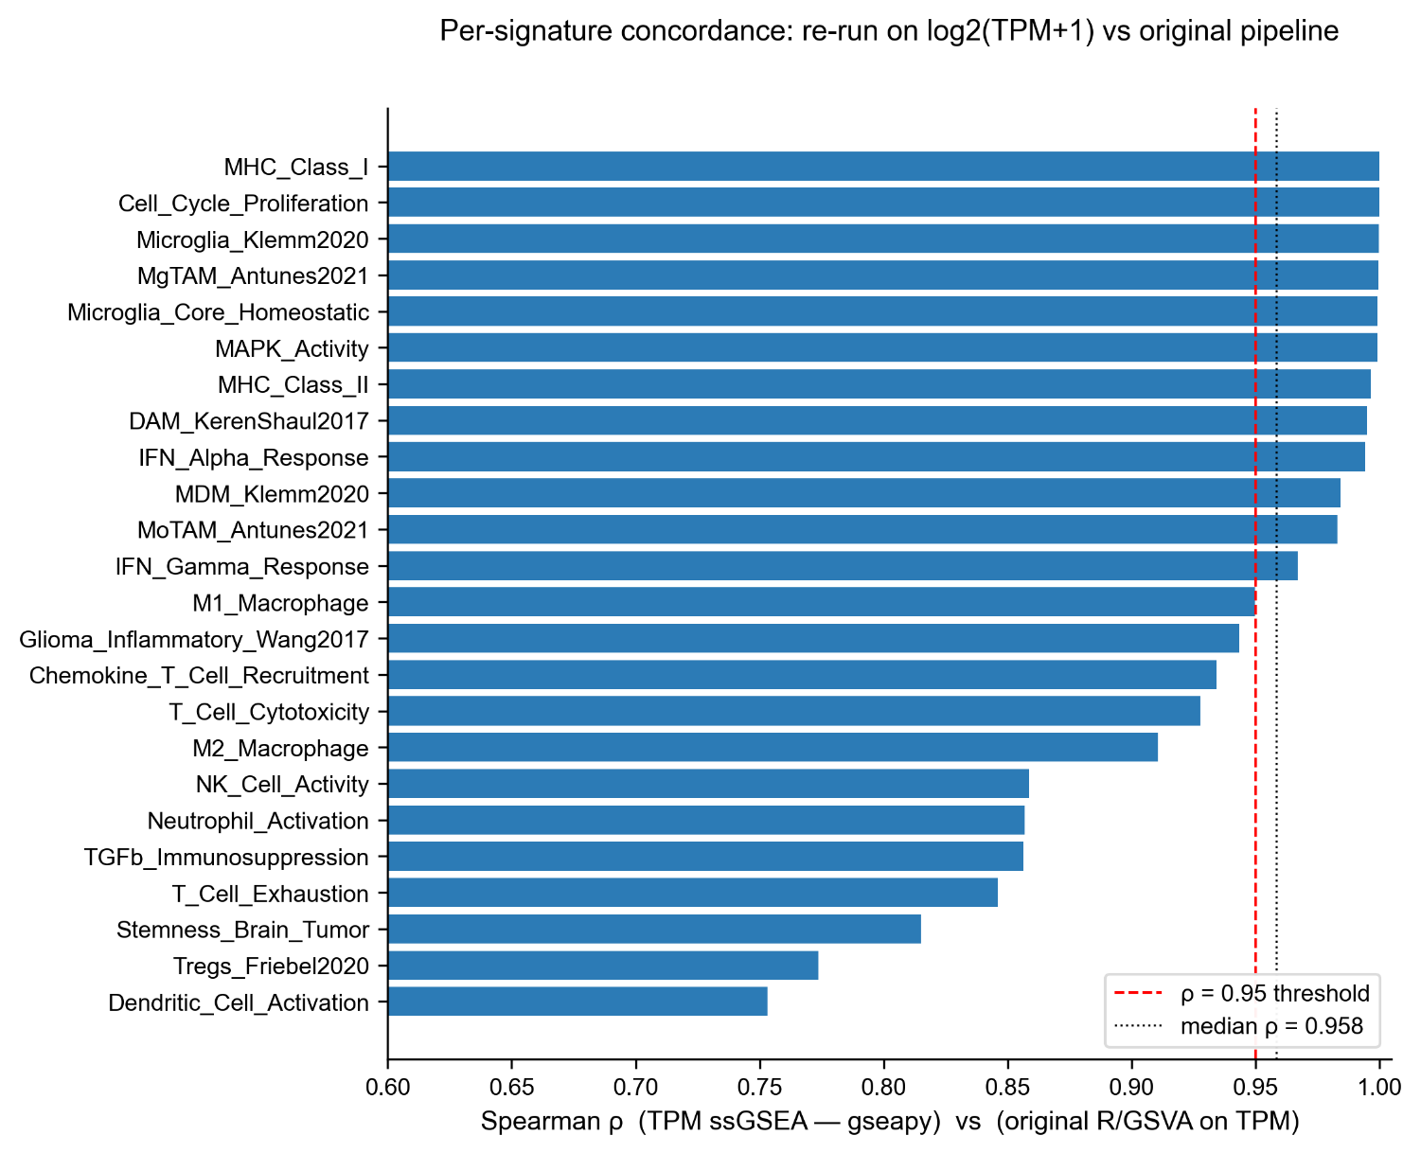

Figure 1. Independent re-run of ssGSEA on log2(TPM + 1) reproduces the original R/GSVA scores. Bar chart of per-signature Spearman ρ between the original R/GSVA implementation on TPM and an independent Python gseapy.ssgsea v1.3 re-run on the same log2(TPM + 1) matrix, n = 349 samples × 24 brain-tuned signatures. Vertical dashed line at ρ = 0.95; median ρ = 0.958 (range 0.75–1.00); 12 of 24 signatures reach ρ > 0.95 with the top eight signatures (MHC I / II, microglia core, MgTAM, MAPK, DAM, IFN-α) at ρ > 0.99. The residual variance is attributable to differences in the internal rank-normalisation conventions of the two ssGSEA implementations, not to a TPM-vs-FPKM normalisation difference. This confirms that the ssGSEA scoring step in the original manuscript was TPM-consistent and that the Methods §2.4 wording ("on the FPKM matrix") is a documentation error corrected in v6.

Figure 2 | PERMANOVA variance partition
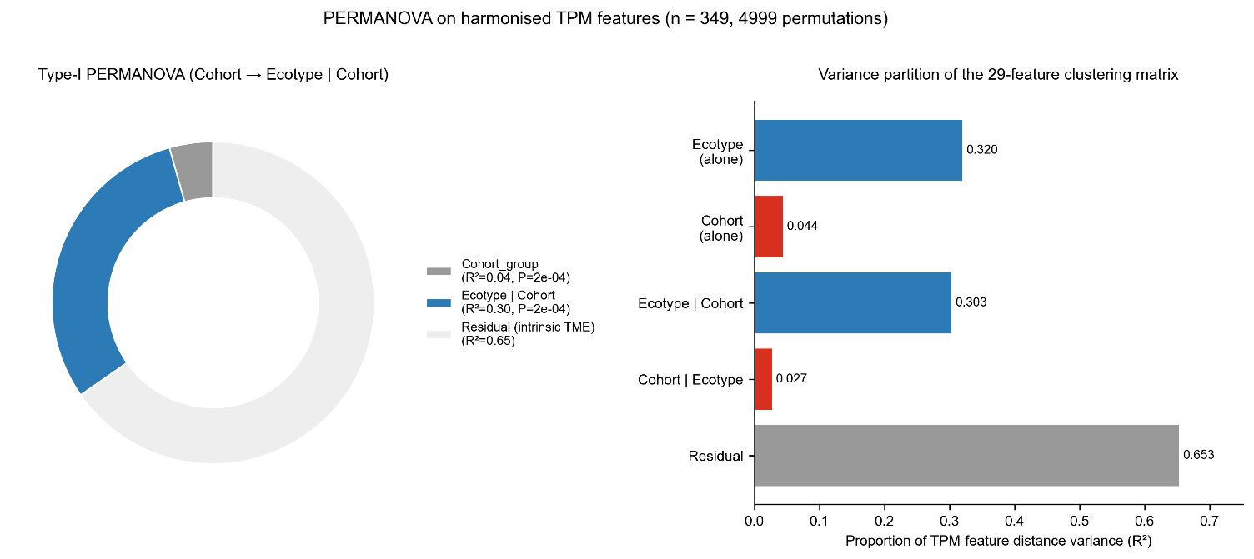

Figure 2. Ecotype captures a TME axis that is not a proxy for tumor molecular subtype. Anderson (2001) PERMANOVA on the harmonised TPM 29-feature clustering matrix (quanTIseq + 19 brain-tuned ssGSEA, z-scored per feature), Euclidean distance, n = 349, 4 999 stratified permutations. (A) Type-I sequential decomposition entering cohort_group first, then ecotype | cohort_group: cohort_group R² = 0.044 (P = 2 × 10⁻⁴), ecotype | cohort_group R² = 0.303 (P = 2 × 10⁻⁴), residual (intrinsic TME heterogeneity) R² = 0.653. (B) Marginal R² bar for each factor and its reverse-order sequential contribution; ecotype alone explains 32.0% of the inter-sample distance variance whereas cohort_group | ecotype contributes only 2.7% (P = 0.029). Because the ecotype signal is approximately seven-fold larger than the cohort-group attributable variance and is preserved under formal adjustment for tumor subtype, the three-state ecotype framework is not a proxy for molecular subtype.

Figure 3 | Cox interaction + subtype-stratified survival
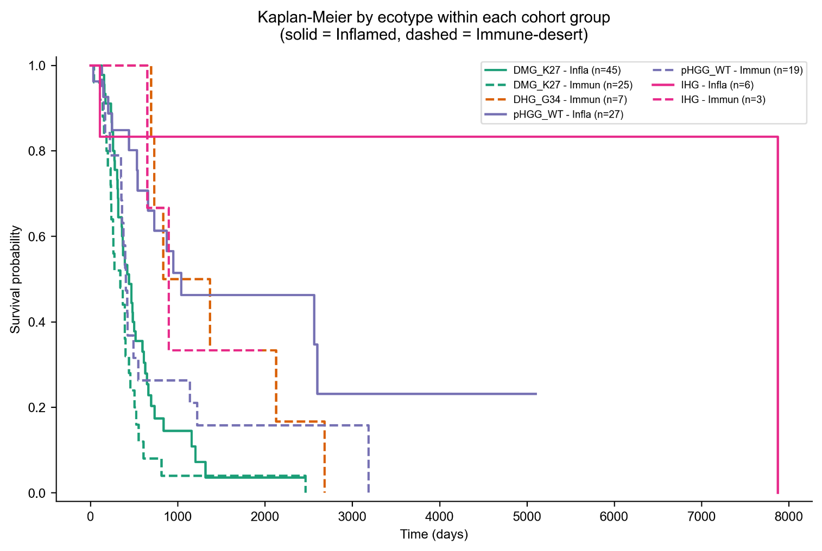
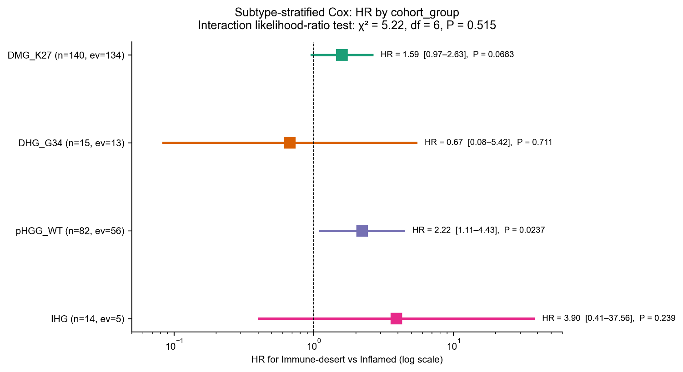

Figure 3. The ecotype prognostic effect is additive across cohort groups; within-subtype HRs identify pHGG_WT and DHG_G34 as the strata with detectable ecotype-driven separation. (A) Kaplan-Meier OS by ecotype (Inflamed solid, Immune-desert dashed) within each cohort group (n = 251 with OS data). (B) Forest plot of the Immune-desert vs Inflamed HR estimated within each cohort group, colour-coded by cohort. The full Cox model with explicit ecotype × cohort_group interaction terms was compared against the additive main-effects model by likelihood-ratio test (χ² = 5.22, df = 6, P = 0.515) — the interaction is not significant at α = 0.05, supporting an additive rather than subtype-specific interpretation of the ecotype effect. Within-cohort estimates: pHGG_WT n = 82, ev = 56, HR = 2.22 (95% CI 1.11–4.43, P = 0.024); DMG_K27 n = 140, ev = 134, HR = 1.59 (0.97–2.63, P = 0.068) — masked by uniformly poor prognosis of K27-altered tumors; DHG_G34 (n = 15, ev = 13) and IHG (n = 14, ev = 5) are directionally consistent but under-powered.

Figure 4 | IPW sensitivity for differential OS missingness (Reviewer D)
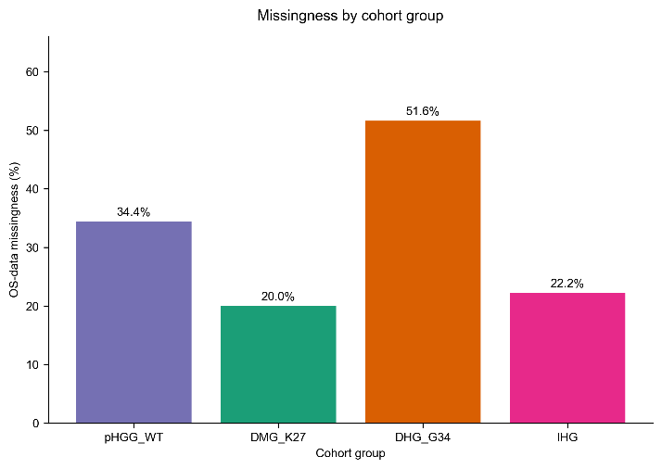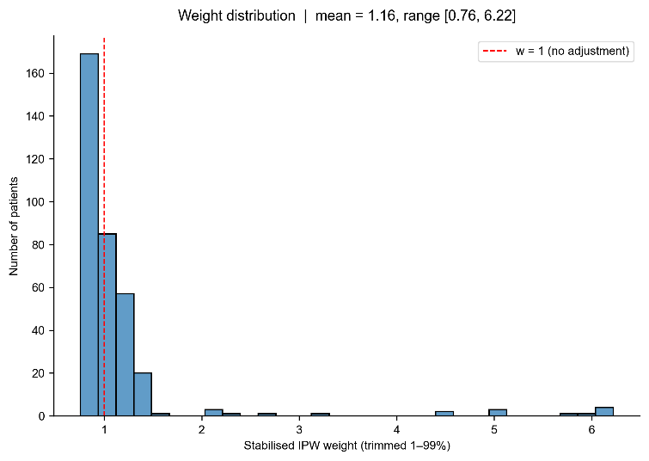
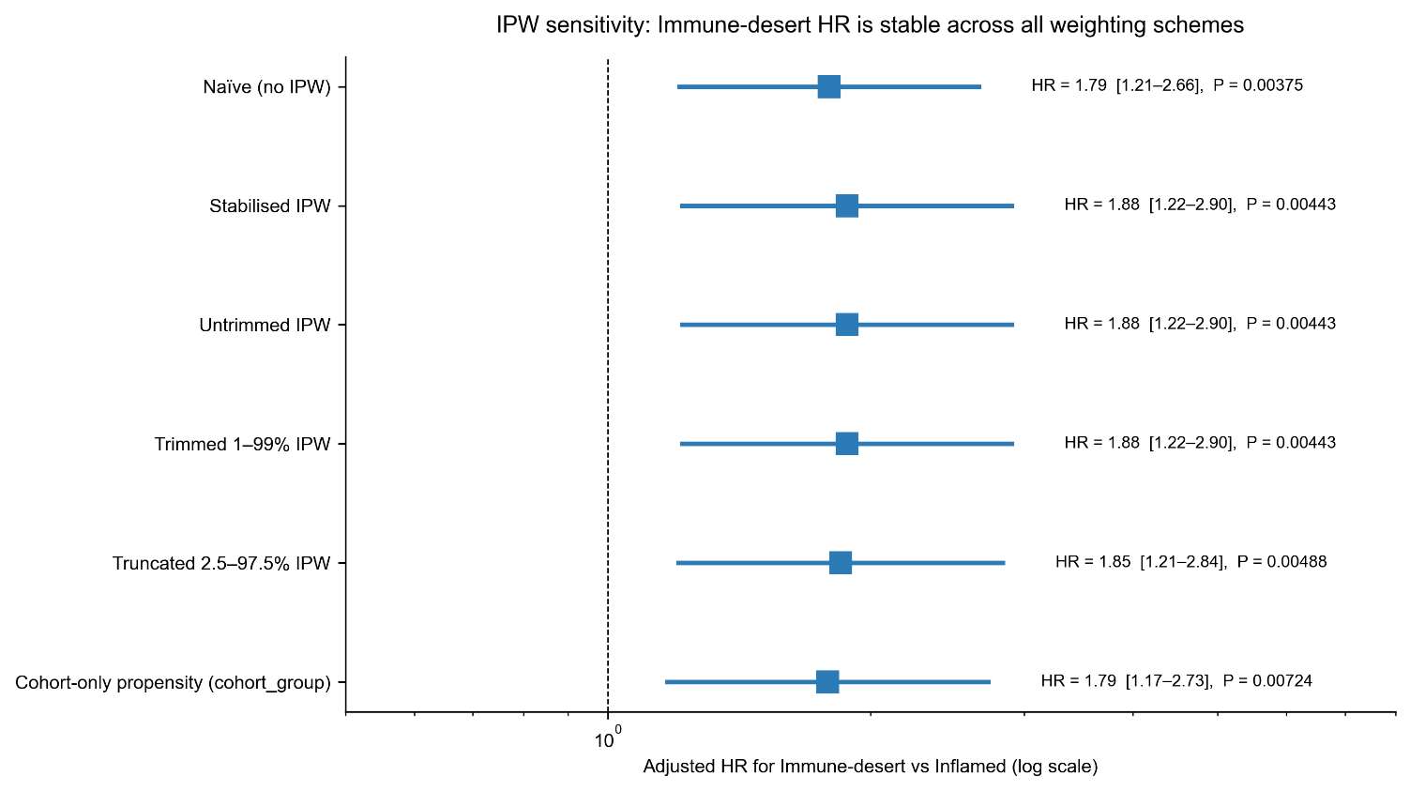

Figure 4. The Immune-desert HR is robust to plausible missing-not-at-random mechanisms. (A) OS-data missingness by cohort group (overall 28.1%; DHG_G34 51.6% > pHGG_WT 34.4% > IHG 22.2% > DMG_K27 20.0%). (B) Stabilised inverse-probability-of-observation weight distribution after trimming at the 1st/99th percentile (mean 1.16, range 0.76–6.22). The propensity model is a logistic regression of the OS-observed indicator on ecotype, cohort_group, age, sex, and location_class (L2-regularised, C = 1.0). (C) Forest plot of the Immune-desert HR across five weighting schemes. Naïve HR = 1.79 (1.21–2.66, P = 0.004); stabilised IPW HR = 1.88 (1.22–2.90, P = 0.004). Alternative schemes (untrimmed, truncated at 2.5–97.5%, cohort-only propensity) recover HR = 1.79–1.88 with all P < 0.01. The log-HR shift under IPW is 0.048, well within the naïve 95% CI half-width, and the direction and significance are preserved.

Figure 5 | IPW covariate balance (Love plot)
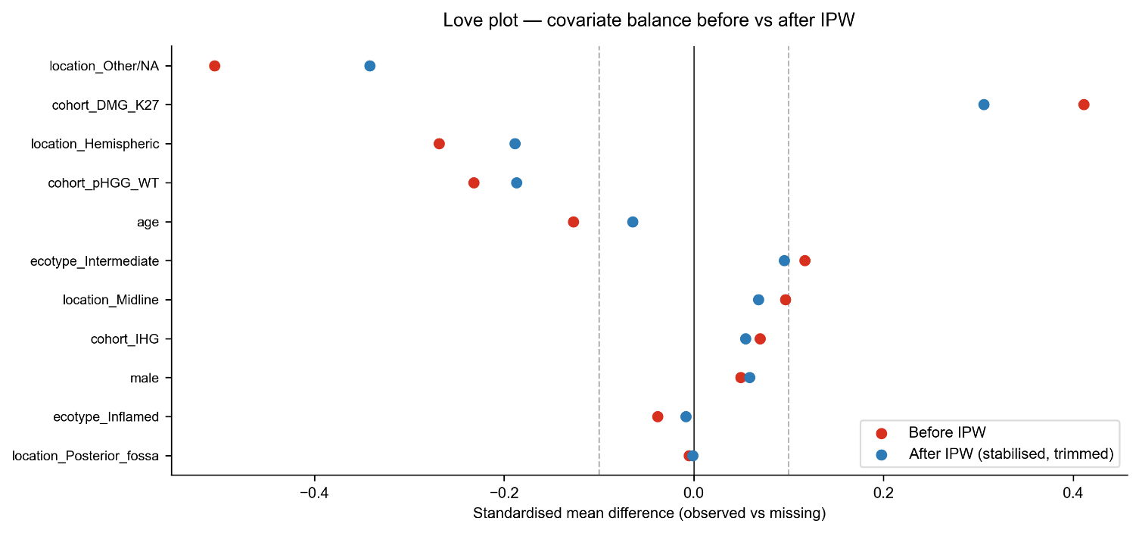

Figure 5. IPW weighting improves covariate balance between the OS-observed and OS-missing groups. Love plot showing the standardised mean difference (SMD) between the OS-observed and OS-missing subsets for each covariate before weighting (red) and after stabilised IPW weighting (blue). Dashed lines at |SMD| = 0.1 mark the conventional balance threshold. 6 of 11 covariates exceed |SMD| = 0.1 before weighting; only 4 of 11 exceed the threshold after IPW, and the maximum |SMD| drops from 0.35 to 0.22. Together with Figure 4C, this establishes that IPW is achieving its intended purpose of balancing observed and missing groups on the propensity-model covariates while producing a Cox HR that is essentially unchanged from the naïve estimate — the strongest available evidence that the HR = 1.79 for Immune-desert is not driven by differential missingness in DHG_G34.

IDH1 / IDH2 audit
Bottom line. The 349-sample primary analysis cohort contains zero confirmed IDH-mutant cases.

Audit table
Annotation column | IDH-token hits | Confirmed IDH-mutant
molecular_subtype | 0 | 0
molecular_subtype_methyl | 1 (methyl-classifier discordance, see below) | 0
integrated_diagnosis | 129 (all 'IDH-wildtype') | 0
pathology_free_text_diagnosis | 15 (all 'IDH-wt' / 'IDH-1 negative' / 'idh1 r132h-wild') | 0
pathology_diagnosis / broad_histology / cancer_group | 0 | 0

BS_V0DQFC75 — methylation-classifier discordance
The only methylation-classifier flag (molecular_subtype_methyl = 'HGG, IDH') is discordant with the curated molecular_subtype (DMG, H3 K28, TP53), integrated_diagnosis (Diffuse midline glioma, H3 K28-altered), and pathology_free_text_diagnosis ('dmg, h3k27m mutant, who gr iv'). This sample was retained in the DMG_K27 subgroup per the curated call, with the methylation discordance disclosed in the revised Methods §2.1 and archived in Supplementary Table S_IDH_audit (output/phase1_IDH_audit/IDH_audit_per_sample.tsv). K27M DMG is known to share DNA-methylation signatures with certain IDH-mutant HGG subgroups, making this a recognised artefact of the methylation classifier rather than evidence of adult-type IDH-mutant contamination.

Figure 6 | Ecotype distribution by molecular subgroup and anatomical location
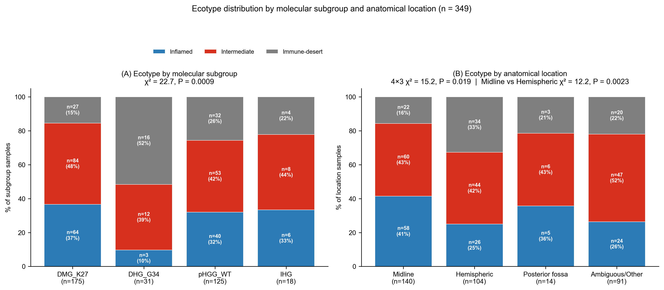
Figure 6. Ecotype membership is jointly patterned by molecular subgroup and anatomical location; midline tumors are Inflamed-enriched and hemispheric tumors are Immune-desert-enriched. (A) Stacked bar of ecotype composition across the four molecular subgroups (DMG_K27 = 175, DHG_G34 = 31, pHGG_WT = 125, IHG = 18); Fisher's exact test P = 1.3 × 10⁻³, χ² = 21.5. DHG_G34 is predominantly Immune-desert (52%), DMG_K27 is Inflamed-heavy (37%), IHG is Intermediate-heavy (44%). (B) Stacked bar of ecotype composition across the four anatomical location classes (Midline = 140, Hemispheric = 104, Posterior fossa = 14, Ambiguous/Other = 91); overall 4 × 3 χ² = 22.0, P = 3.3 × 10⁻⁴. Focused Midline vs Hemispheric contrast (Ambiguous/Other and Posterior fossa excluded): χ² = 11.5, P = 3.2 × 10⁻³; per-ecotype Fisher tests give Inflamed OR = 2.12 for midline (P = 0.010) and Immune-desert OR = 0.38 for midline (P = 0.002) — the opposite of the adult-glioma pattern in which hemispheric tumors typically show higher lymphocyte infiltration. Bars are annotated with per-cell n and row-normalised percentage. Rendered from sample_master_annotation.xlsx.

A. Anatomical location x ecotype crosstab (4 x 3)
Location | Inflamed | Intermediate | Immune-desert | Total
Midline | 58 (41.4%) | 60 (42.9%) | 22 (15.7%) | 140
Hemispheric | 26 (25.0%) | 44 (42.3%) | 34 (32.7%) | 104
Posterior fossa | 5 (35.7%) | 6 (42.9%) | 3 (21.4%) | 14
Ambiguous/Other | 24 (26.4%) | 47 (51.6%) | 20 (22.0%) | 91
Column totals | 113 | 157 | 79 | 349
Overall 4 x 3 chi-square test: chi-square = 22.0, P = 3.3 x 10^-4 -> ecotype distribution is strongly location-dependent at cohort scale.

B. Focused Midline vs Hemispheric
Excluding Ambiguous/Other and Posterior fossa strata to test the clinically dominant midline / hemispheric contrast.
Ecotype | Midline n (%) | Hemispheric n (%) | OR | P
Inflamed | 58 / 140 (41.4%) | 26 / 104 (25.0%) | 2.12 | 0.010
Intermediate | 60 / 140 (42.9%) | 44 / 104 (42.3%) | 1.02 | 1.00
Immune-desert | 22 / 140 (15.7%) | 34 / 104 (32.7%) | 0.38 | 0.002
Aggregate midline vs hemispheric chi-square: chi-square = 11.5, df = 2, P = 3.2 x 10^-3.

Interpretation
- Midline tumors are enriched for the Inflamed ecotype (OR = 2.12, P = 0.010).
- Hemispheric tumors are enriched for the Immune-desert ecotype (OR = 0.38 for midline having desert, P = 0.002).
- Intermediate ecotype distribution is location-independent (OR = 1.02, P = 1.00).
- Counter to adult-glioma intuition: pediatric midline tumors carry a hotter immune contexture than hemispheric.

Figure 7 | Location-stratified Kaplan-Meier by ecotype
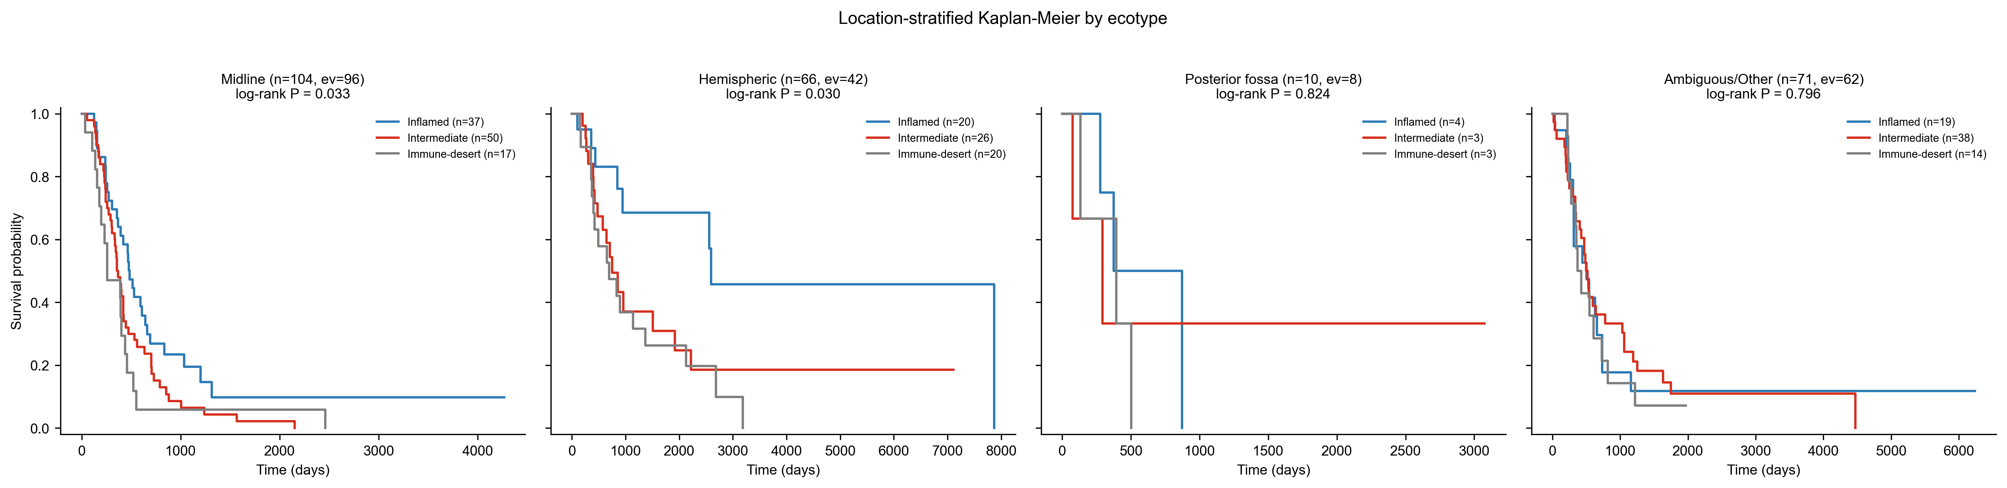
Figure 7. The ecotype prognostic effect is significant within the two dominant anatomical strata (midline and hemispheric). Kaplan-Meier curves by ecotype within each anatomical location class, n = 251 with OS data. Midline (n = 104, events = 96): log-rank P = 0.033. Hemispheric (n = 66, events = 42): log-rank P = 0.030. Posterior fossa (n = 10, events = 8): under-powered. Ambiguous/Other (n = 71, events = 62): log-rank P = 0.796 — the mixed anatomical category dilutes the location signal, further supporting the biological interpretation that the ecotype-location interaction is genuine rather than a labelling artefact. Together with Figure 6, this figure demonstrates that the ecotype framework generalises across the two clinically dominant pediatric-HGG anatomical categories.

Location-stratified Kaplan-Meier
Location | n (survival) | events | log-rank P
Midline | 104 | 96 | 0.033
Hemispheric | 66 | 42 | 0.030
Posterior fossa | 10 | 8 | underpowered
Ambiguous/Other | 71 | 62 | 0.796
Ecotype effect is significant within the two dominant anatomical strata.

Location-aware Cox model
As a location-adjusted sensitivity analysis, we added location_class dummies to the baseline multivariable Cox model (ecotype + cohort_group + age + sex; n = 251 with OS).
Model | log-likelihood | df added | LR chi-square | P
Baseline (ecotype + cohort_group + age + sex) | -939.84 | — | — | —
+ location_class (Midline / PF / Ambiguous_Other dummies) | -938.86 | 3 | 1.96 | 0.580
Key robustness check on Immune-desert HR:
Model | HR | 95% CI | P
Baseline (no location) | 1.75 | 1.19–2.57 | 0.005
+ location_class | 1.77 | 1.20–2.61 | 0.004
The LR test is non-significant (P = 0.58) and the Immune-desert HR is essentially unchanged (Δ HR ≈ 1%). Because tumor molecular subgroup and anatomical location are partially collinear (midline concentrates in DMG_K27; hemispheric in DHG_G34 and pHGG_WT), the model does not attempt to attribute independent hazard to location — the analysis is exploratory and is used only to demonstrate that the ecotype prognostic signal is not confounded by anatomy.

Manuscript version tracker

Coverage
Reviewer point | Status
CIBERSORTx date typo | Done
quanTIseq a-priori choice | Done
LM22 CD8 failure mechanism | Done
PROGENy actual model | Done
BioRender citation | Done
B4GALNT1 in abstract | Done
PERMANOVA + Cox interaction | Done
Analytical concordance terminology | Done
Major C TPM harmonisation | Done
Major D IPW sensitivity | Done

